Sprint 3

|  |  |
| --- | --- |
| Date | 15-11-2022 |
| Team ID | PNT2022TMID12349 |
| Project Name | Personal Assistance for Seniors Who Are Self- Reliant. |

IBM Watson IOT Platform

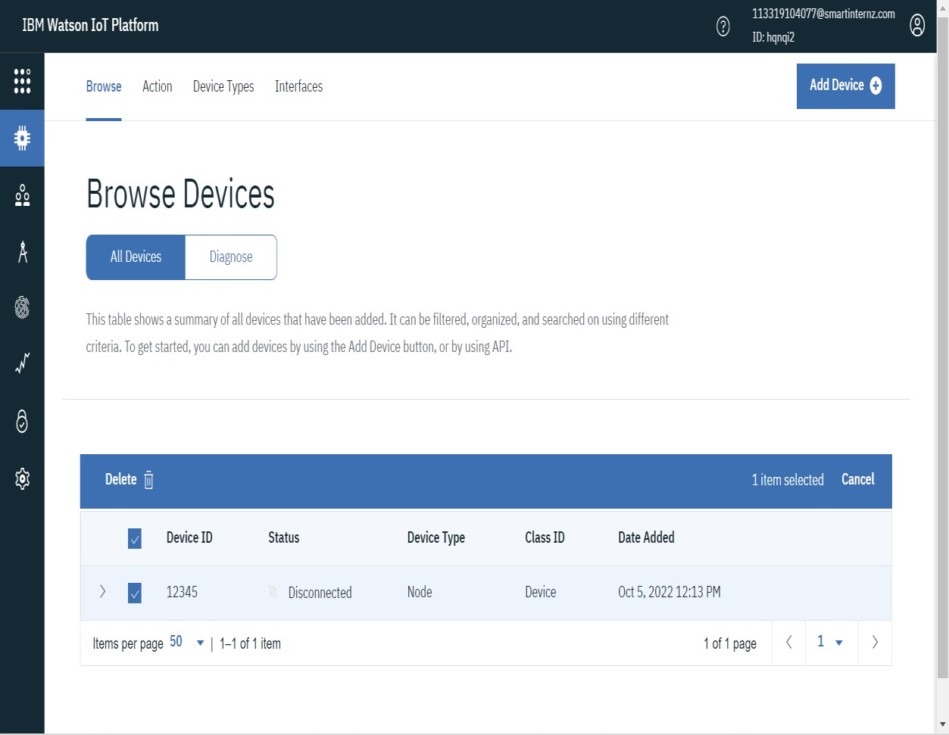

Node-Red Flow for searching data in cloudant and sending it to IBM Watson IOT device.

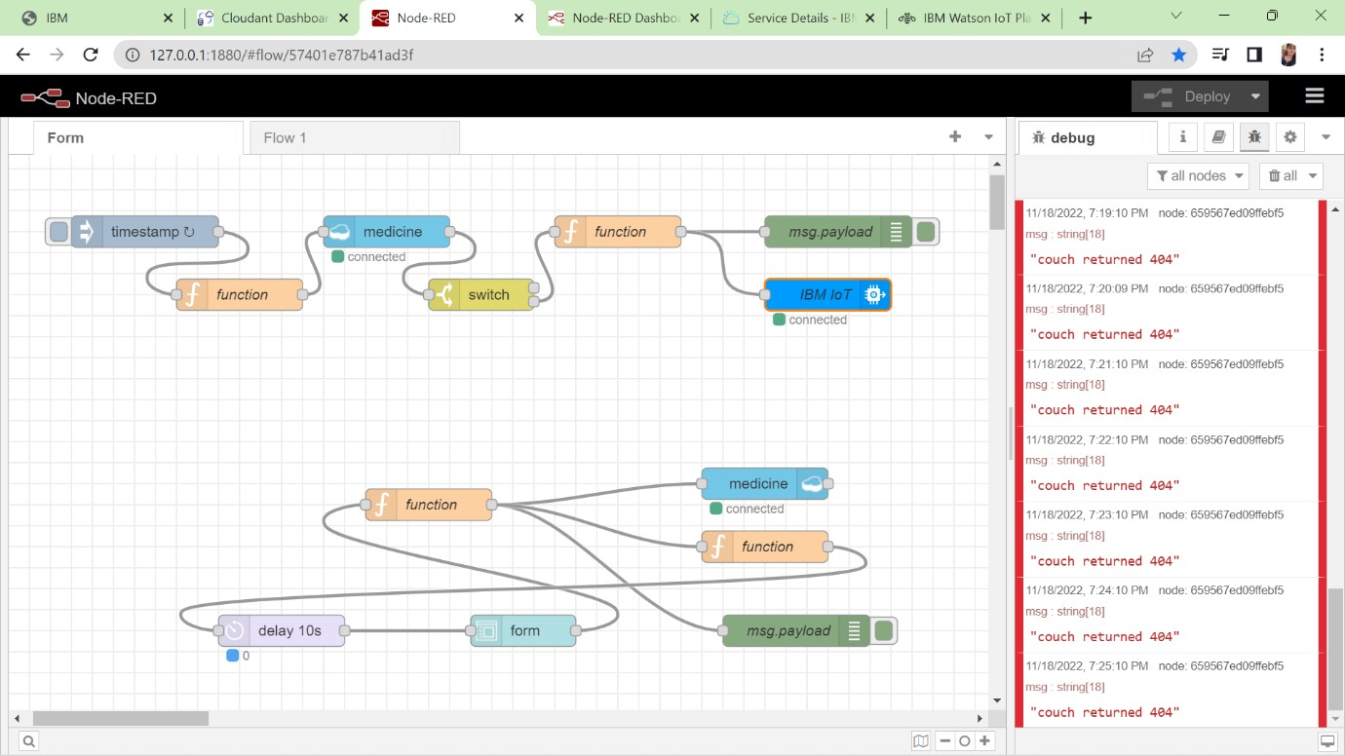

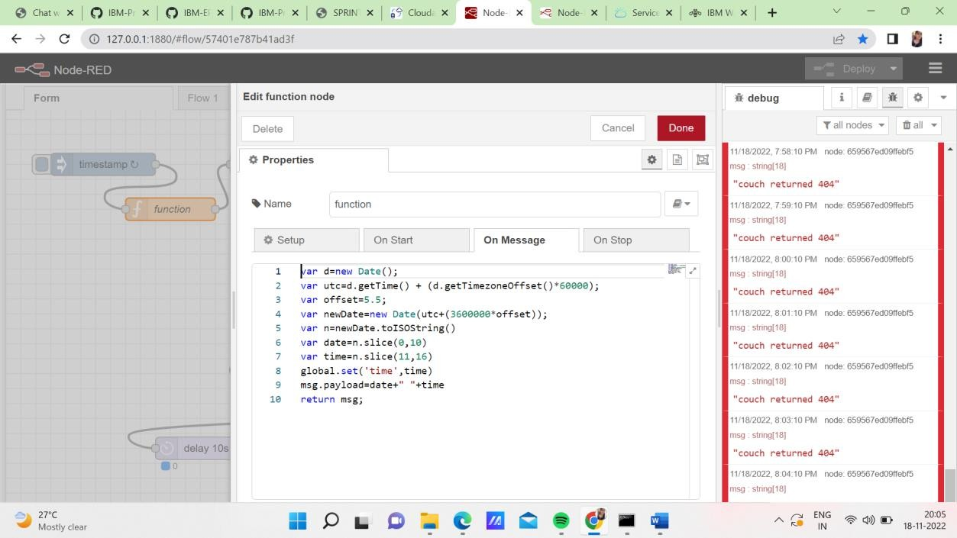

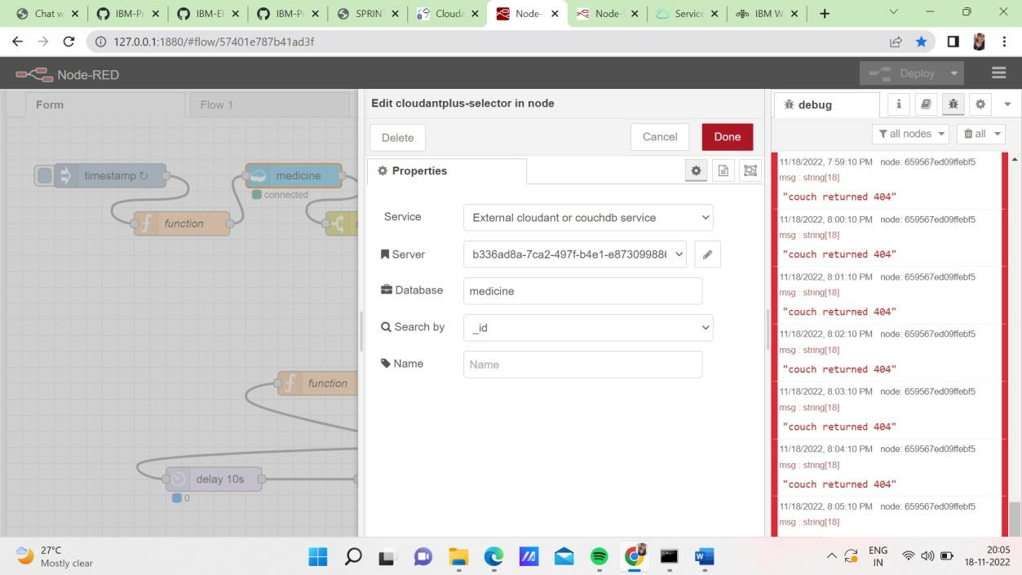

Connecting to the Board

